|  |
| --- |
|  |

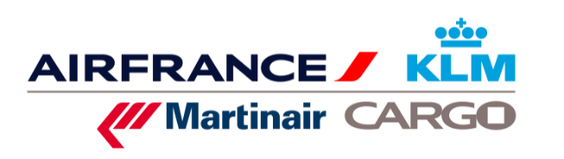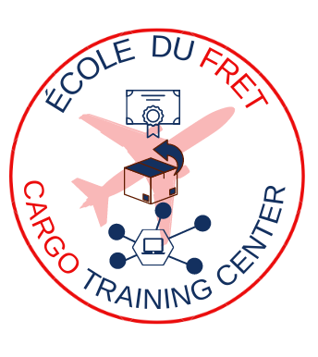

**E-LEARNING REGISTRATION FORM**

|  |  |
| --- | --- |
| **BUSINESS** | |
| COMPANY NAME |  |
| FULL POSTAL ADDRESS |  |
| INTRA COMMUNTY VAT NUMBER AND/OR SIRET |  |
| TRAINING MANAGER | NAME :  TEL :  MAIL : |
| BILLING DEPARTMENT | NAME :  TEL :  MAIL : |

|  |
| --- |
|  |

|  |
| --- |
| **PAYMENT** |



BY SUBROGATION VIA OPCO (AFTER TRANSMISSION OF THE AGREEMENT FOR FUNDING APPROVAL)

ORDER NUMBER

BY BANK TRANSFER IN EUROS (BANK DETAILS IN THE CONVENTION)

BY DIRECT DEBIT

REQUEST DATE

**Air France Cargo School 12 Rue du Tarteret 95747 Roissy Charles de Gaulle Cedex France   
Phone: + 33 (0)1 41 56 95 74 mail: mail.ecole_du_fret**[**@airfrance.fr**](mailto:nalemarchand@airfrance.fr) **Intra-community VAT number FR 61 420 495 178   
 SIRET 42 04 95 17 80 00 14**

**REGISTRATION**

E-learning access: Your e-learning training will be accessible for 45 days from the convention signing date.

|  |  |  |  |
| --- | --- | --- | --- |
| **TRAINEES** | | **TRAINING SESSIONS** | |
| **LAST NAME**  **(Specify Mr or Mrs)** | **FIRST NAME** | **E-LEARNING TITLE** | **PRICE € EXCL VAT** |
|  |  |  |  |
|  |  |  |  |
|  |  |  |  |
|  |  |  |  |
|  |  |  |  |
|  |  |  |  |
|  |  |  |  |