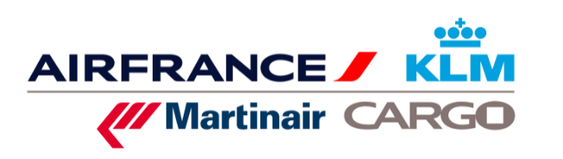

ORDER NUMBER

**REGISTRATION FORM**

|  |  |
| --- | --- |
| **BUSINESS** | |
| COMPANY NAME |  |
| FULL POSTAL ADDRESS |  |
| BILLING ADDRESS |  |
| INTRA COMMUNTY VAT NUMBER AND/OR SIRET |  |
| MANAGER’S NAME, PHONE NUMBER AND EMAIL ADRESS[1] |  |
| BILLING MANAGER’S NAME[2] |  |

|  |
| --- |
|  |

|  |
| --- |
|  |

|  |
| --- |
| **PAYMENT** |

 Reminder concerning dangerous goods recycling trainings

BY SUBROGATION VIA OPCO (AFTER TRANSMISSION OF THE AGREEMENT FOR FUNDING APPROVAL)

BY BANK TRANSFER IN EUROS (BANK DETAILS IN THE CONVENTION)

BY DIRECT DEBIT

REQUEST DATE

**Air France Cargo School 12 Rue du Tarteret 95747 Roissy Charles de Gaulle Cedex France   
Phone: + 33 (0)1 41 56 95 74 mail: mail.ecole_du_fret**[**@airfrance.fr**](mailto:nalemarchand@airfrance.fr) **Intra-community VAT number FR 61 420 495 178   
 SIRET 42 04 95 17 80 00 14**

**REGISTRATION**

You MUST provide us with the trainee’s latest certificate to confirm registration. Registration for a dangerous goods recycling course can be brought forward by a maximum of 3 months from the date the certificate expires. If you pass the final test, the certificate will retain the same expiry date plus x months.

|  |  |  |  |  |  |  |  |
| --- | --- | --- | --- | --- | --- | --- | --- |
| **TRAINEES** | | | **TRAINING SESSIONS** | | | | |
| **LAST NAME**  **(specify Mr or Mrs)** | **FIRST NAME** | **Profession** | **TITLE OF THE TRAINING** | **START DATE (dd/mmm/yyyy)** | **END DATE (dd/mmm/yyyy)** | **LOCATION** | **PRICE € EXCL VAT** |
|  |  |  |  |  |  |  |  |
|  |  |  |  |  |  |  |  |
|  |  |  |  |  |  |  |  |
|  |  |  |  |  |  |  |  |
|  |  |  |  |  |  |  |  |
|  |  |  |  |  |  |  |  |
|  |  |  |  |  |  |  |  |

1. The manager in charge of the organization of the training
2. Financial department